>exploraciones:

§ Tubará....................................................................................1883.
§ Tubará 1.................................................................................1946.
§ Tubará 2.................................................................................1947.
§ West Pérdices........................................................................1948.
§ Tubará 3.................................................................................1953.
§ Tubará 4.................................................................................1959.
§ Guaruco 3...............................................................................1961.
§ Guaruco 1...............................................................................1962.
§ Guaruco 2...............................................................................1962.
§ Apolo 1...................................................................................1981.
§ Géminis 2...............................................................................1982.

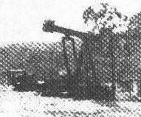
Machín, en la Propiedad Privada de Tubará (A).

>compañias:
§ Compañia de Petróleos del Carare................................1939-1945.
§ Tropical Oil Co.(Troco)................................................1945-1951.
§ Internacional Oil Co.(Intercol).....................................1951-1961.
§ Anson Petroleum Corp.................................................1961-1962.
§ Drillesco........................................................................1981-
§ Allied Energy Corp.......................................................1996-

